How to setup google colab to GitHub through gitbash

This documentation was made to demonstrate how to set up google colab to work with Github using Git Bash. This documentation shows the steps using Windows 10.

**Steps to follow to setup Google Colab to work with Github using Git Bash**

Step 1: Install Git Bash:If you haven't already, download and install Git Bash on your computer. You can download it from the official website: [Git - Downloads (git-scm.com)](https://git-scm.com/downloads)

Step 2: You should have created a branch in Github with MOP-CODE downloaded on your local machine with your name folder within Playground folder. If you haven’t, please follow the github tutorial pdf posted in files of T3 MOP data science chat group.

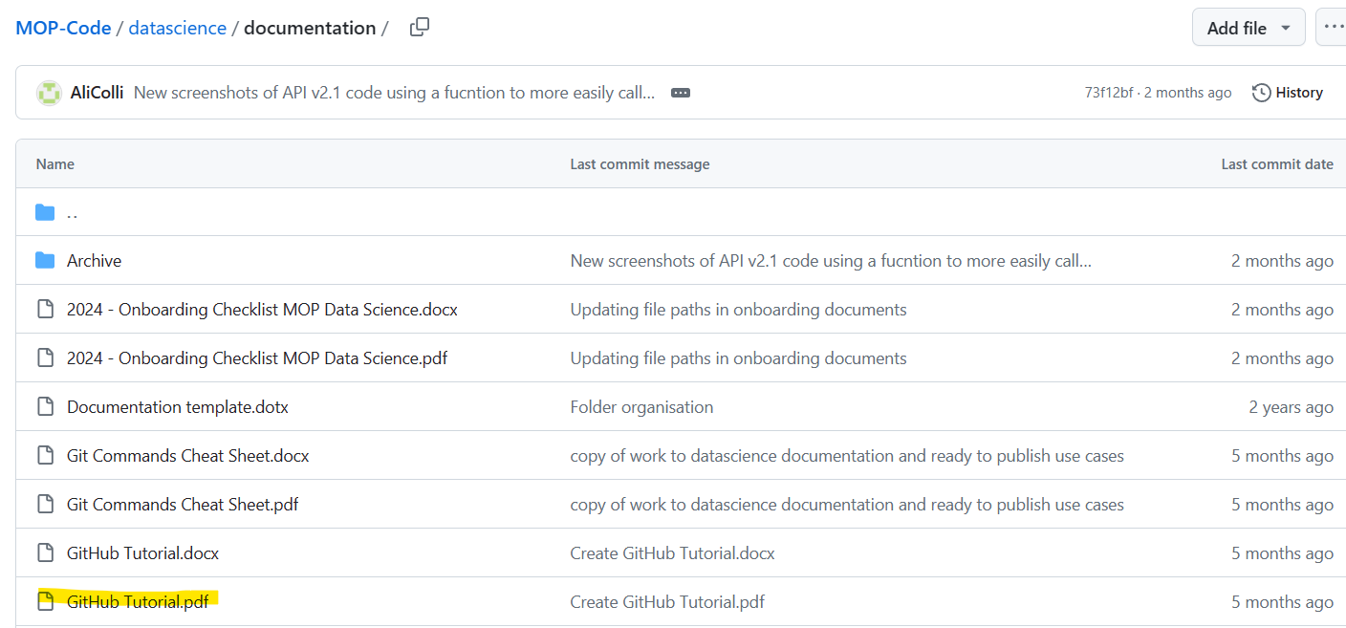

Step 3: Open your web browser and go to [Google Colab](https://colab.research.google.com/).

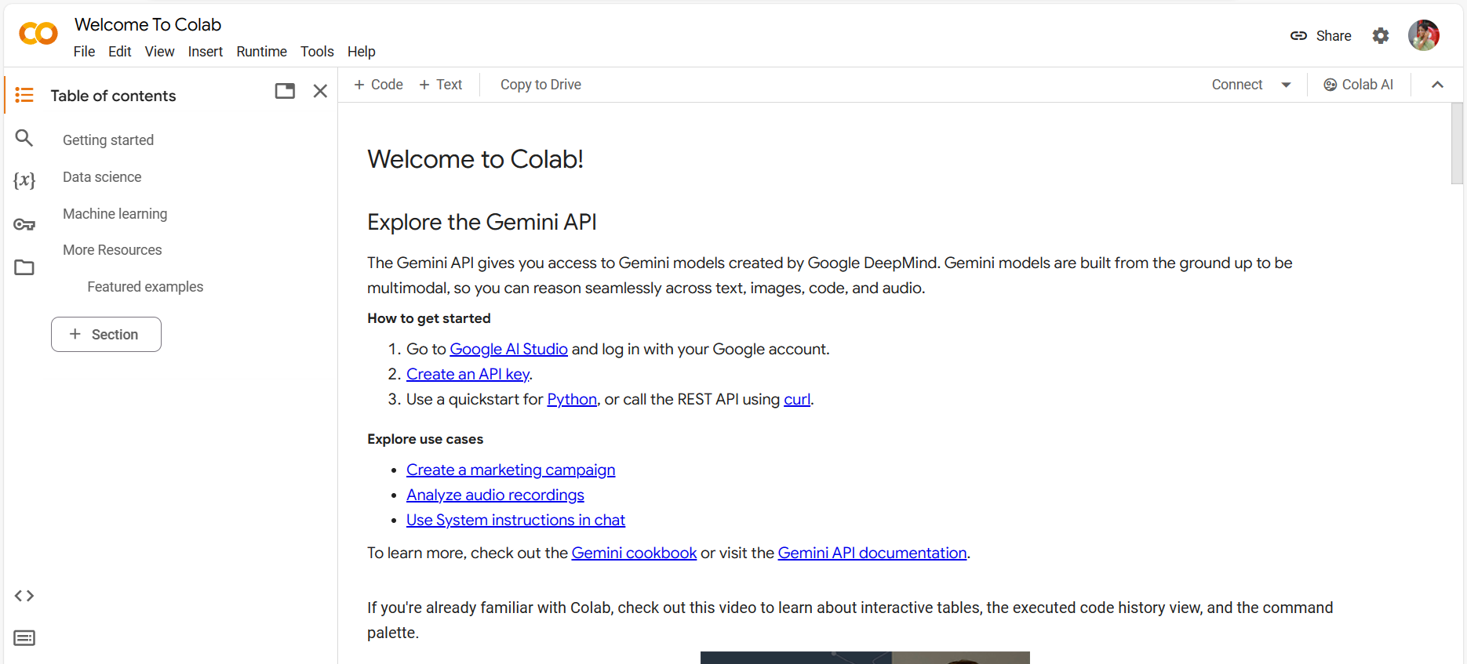

Step 4: In Google Colab, click on "File" in the top-left corner and Select "Open notebook" and click on GitHub and Follow the instructions to authorize access to your GitHub account.

Step 5: Enter the GitHub URL of Chameleon company by ticking the box on “include private repos”

Step 6: Select Repository “Chameleon- company/MOP-Code” and Select your Branch Name “Manasa”

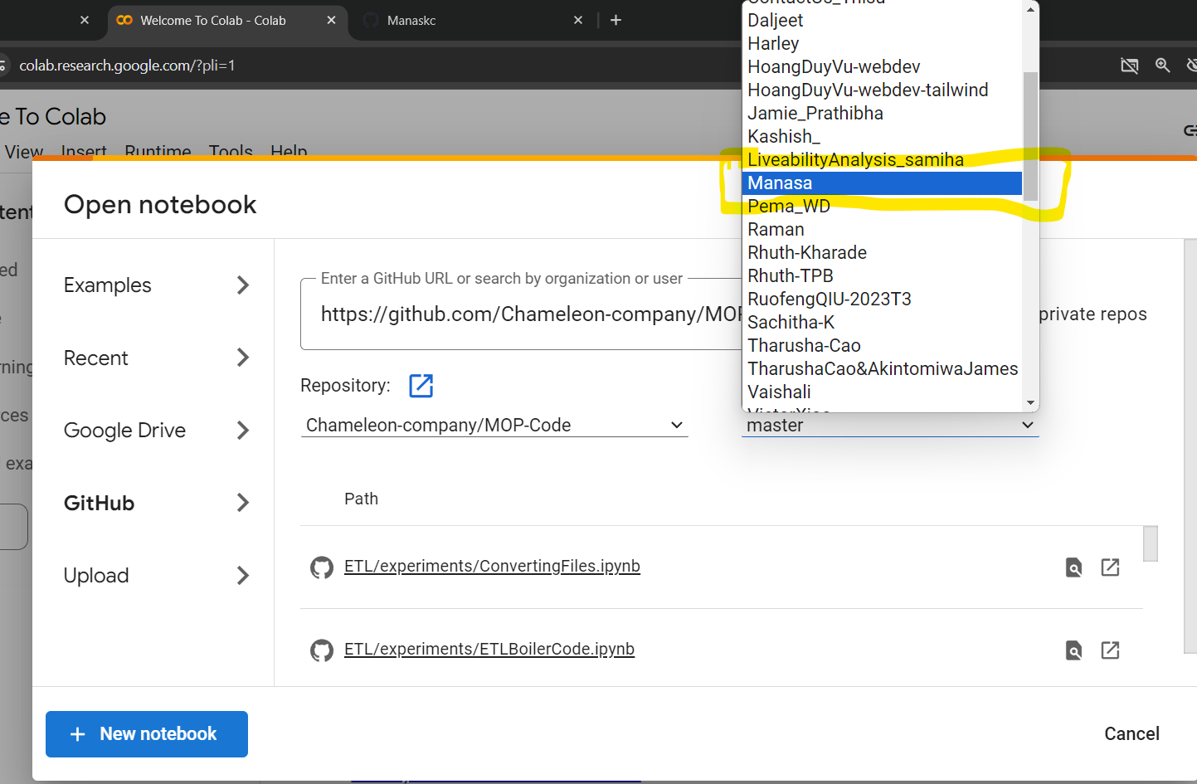

Step 7: In Google Colab, navigate to the directory by clicking on upload and browse and navigate to your local repository

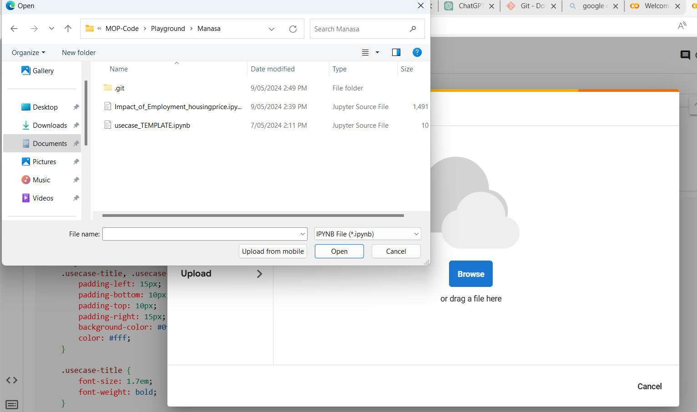

Step 8: Locate your playground folder in your local machine and Click on your own name folder within the playground and click on it and Click on the path and copy it and Right Click on this blank area and click on “Git Bash Here’

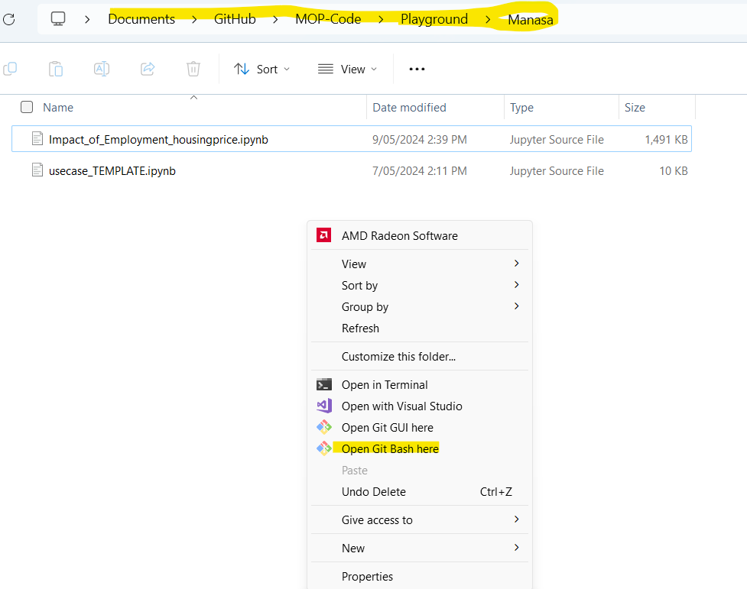

Step 9: Type “git init”. It will create a hidden .git folder in your Playground folder (current working directory)

Step 10: Make changes in your usecase_TEMPLATE.ipynb and save your work (Ctrl + S)

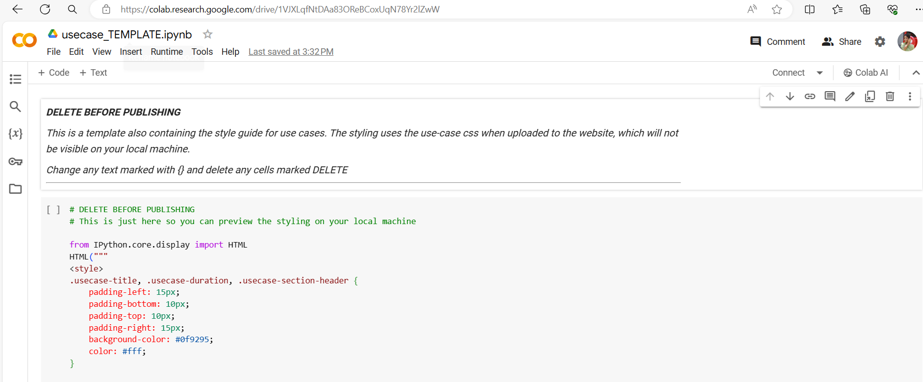

Step 11: Close the git bash and open the playground folder (not your name folder but the plays=ground folder itself). Right Click à Open Git Bash Here  and Type Fetch origin in your git bash

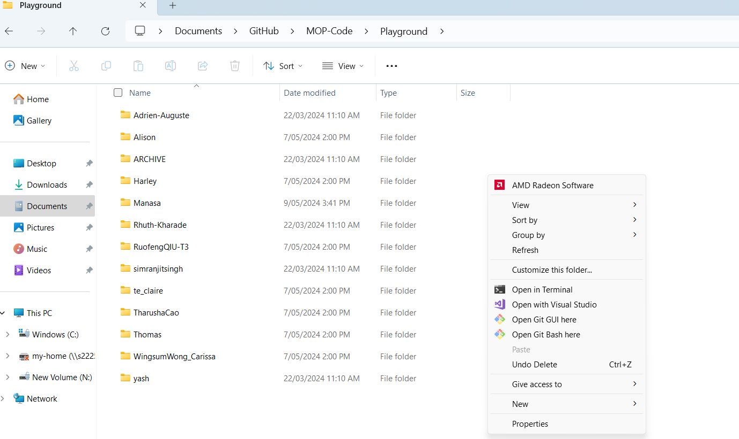

Step 12. Type  git add .

Step 13. Type   git commit -m ‘your message here’

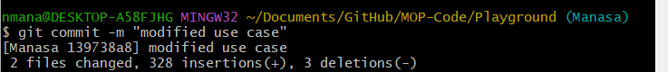

Step 14. Type git push to push your changes made in Google Colab

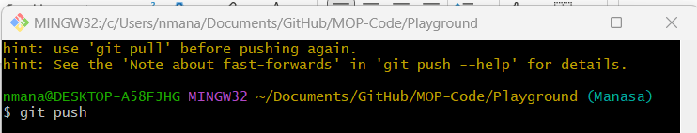

After pushing your changes, verify that they appear on your GitHub repository's

For further GitHUb Command Cheat Sheet , please follow the Git Command sheets pdf posted in files of T3 MOP data science chat group.

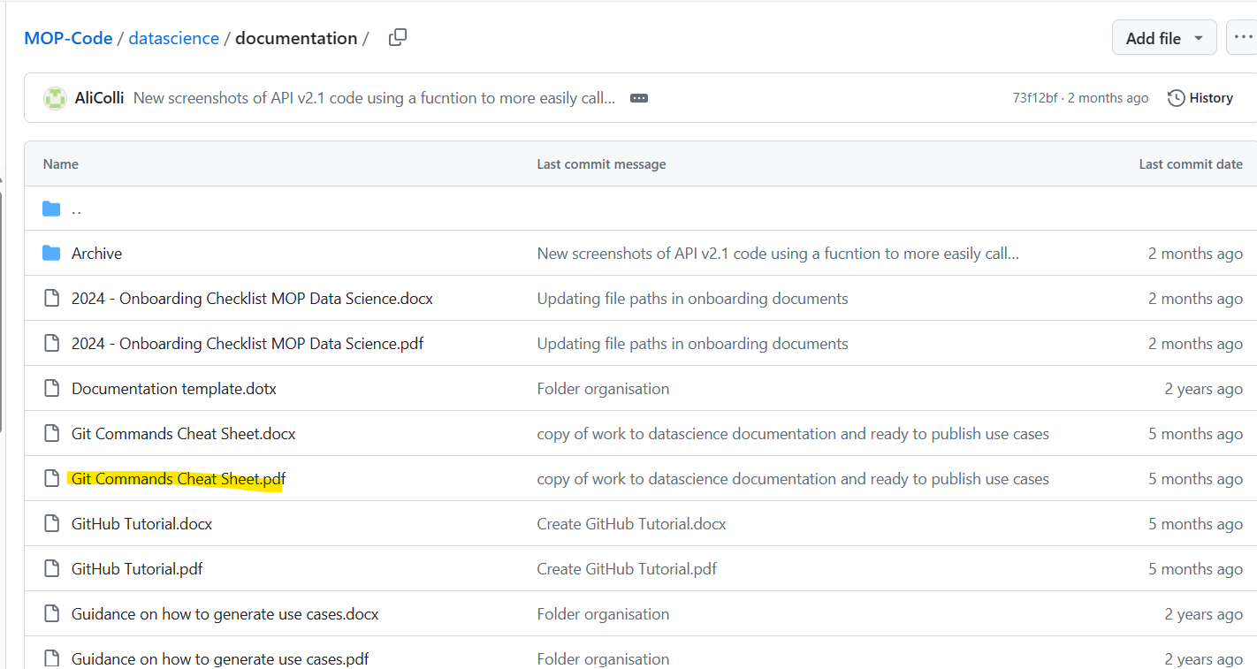

## Author

Manasa Nagaraja

3/5/2024